Table of Contents

Page

Acknowledgements 2

About the University and the Honors Program 3

Guest Speaker 4

Events on Friday, March 17th 5

Events on Saturday, March 18th 6-9

Map of Student Union

Acknowledgements

I would like to take the opportunity to thank a number of people who made this possible. No undertaking this large is ever created by one person. The first people I wish to thank are the staff and students of the Honors Program, without whose help this would never had happened. SpeciaI thanks to Professor Mary Ellen Stegall, Mr. Ryan Winters, Mrs. Angela Ardoin, and Mr. Jason Suire. I also wish to acknowledge the computers provided by Dr. David M. Bellar and Chris Landry from the Kinesiology. Additional thanks to our Dean Bobbie DeCuir for her constant support of our efforts. I need, also, to acknowledge the directors and staff at the UL Lafayette Student Union for graciously making their buildings available to us on a hectic weekend. Lastly, I wish to acknowledge all the time and energy that the faculty and students who attend this conference expend to create their work and to come to Lafayette to share it.

About the University of Louisiana at Lafayette
Founded in 1900, the University of Louisiana at Lafayette (then the Southwestern Louisiana Industrial Institute, the largest member of the University of Louisiana System, is a public institution of higher education offering Bachelor’s, Master’s, and Doctoral degrees. Within the Carnegie classification, UL Lafayette is designated as a research university with high research activity. The University’s academic programs are administered by the Colleges of Arts, Education, Engineering, General Studies, Liberal Arts, Nursing & Allied Health Professions, Sciences, the B.I. Moody III College of Business Administration, and Graduate School.
The University is dedicated to achieving excellence in undergraduate and graduate education, in research, and in public service. For undergraduate education, this commitment implies a fundamental subscription to general education, rooted in the primacy of the traditional liberal arts and sciences as the core around which all curricula are developed. The graduate programs seek to develop scholars who will variously advance knowledge, cultivate aesthetic sensibility, and improve the material conditions of humankind. The University reaffirms its historic commitment to diversity and integration.
Thus, through instruction, research, and service, the University of Louisiana at Lafayette promotes regional economic and cultural development, explores solutions to national and world issues, and advances its reputation among its peers.

About the University Honors Program
The Honors Program at the University of Louisiana at Lafayette provides serious and highly motivated undergraduate students with an enhanced set of educational opportunities so that those students who seek added dimension, enrichment, and challenge in their studies may find realization of their potential. In a society where Honors programs are short-lived and superior education is no longer highly valued, UL Lafayette stands proud as one of the earliest established programs of its kind in Louisiana.
With over 1,100 students, the UL Lafayette Honors Program, one of the largest in the state, is an active member of the Louisiana, Southern Regional, and National Honors Councils. We are known nationwide as leaders in collegiate Honors education. The program is based on the philosophy per sapientiam felicitas – “through knowledge, happiness”.

Guest Speaker

Taniecea Arceneaux Mallery, Ph.D.

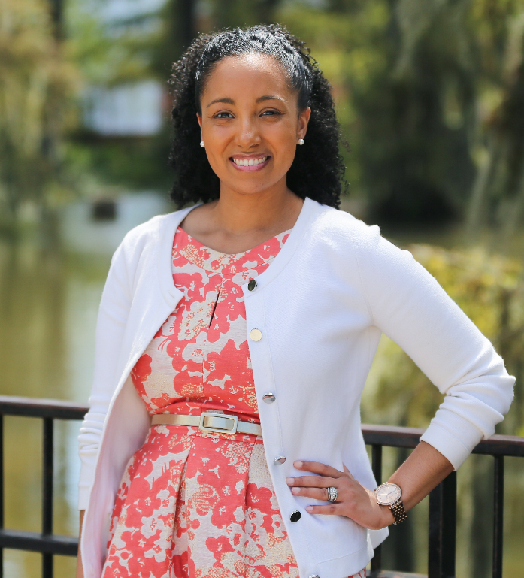

Dr. Taniecea Arceneaux Mallery currently serves as the Director of Equity, Diversity and Community Engagement at the University of Louisiana at Lafayette. In this role, she is responsible for fostering diversity among students, faculty and staff, as well as ensuring that underrepresented groups have equal access to educational opportunities and resources. She is also a member of the graduate faculty, teaching doctoral-level courses in the College of Education.

Prior to joining UL Lafayette, Dr. Mallery worked as a senior diversity research specialist at the Association of American Medical Colleges in Washington, D.C., and she completed a postdoctoral research fellowship at the U.S. Census Bureau. Her recent publications include national policy reports on diversity in the U.S. physician workforce, research in disparities driven by social determinants of health, and studies on the influence of medical school curriculum on where physicians choose to practice.

Dr. Mallery earned a bachelor’s degree in mathematics from Loyola University New Orleans, as well as a master’s degree and Ph.D. in applied and computational mathematics from Princeton University. She has recently been named a Chief Diversity Officer Fellow for the National Association of Diversity Officers in Higher Education.

In the local community, she currently serves on the Board of Directors for the Leadership Institute of Acadiana, the United Way of Acadiana and the Ernest J. Gaines Center at UL Lafayette. She also serves as a member of the Editorial Board for The Daily Advertiser. She is a member of Leadership Lafayette, Class XXIX, and a recent recipient of the 20 Under 40 Young Leader Awards. She is the owner of Diverse City Labs, LLC, a consulting firm providing expertise and coaching in diversity and inclusion for individuals and organizations.

FRIDAY, MARCH 17, 2017

4:00-6:00 Check-in at table in front of the Atchafalaya Ballroom on First Floor of Student Union.

6:00-8:00 Atchafalaya Ballroom

Dinner – Cruise along the Bayou with a Cajun Buffet – Fish or Jambalaya

7:00 – Doctors without Borders Challenge – Fatima Fazal-ur-Rehman

7:30 – “Embracing Leadership through Diversity”
Speaker – Tenicea Mallery, Director of Equity, Diversity and Community Engagement at the University of Louisiana

8:00 Entertainment

Vermilion Room – Table Top Gaming and Pictionary

Bayou Bijou – Movie – “Schultze Gets The Blues” – The bittersweet story of a German who falls in love with Cajun/Creole Music and despite pressure from everyone manages to fight his way to Louisiana. Follow Your Dreams!!!

Atchafalaya Ballroom – Stay with us and enjoy dancing to the hits of several decades.

SATURDAY, MARCH 18, 2017

8:30 Continental Breakfast and Coffee available on second floor in front of elevator.

QUIZ BOWL

8:30 All QUIZ BOWL teams must be present at 8:30 to choose order of competition.

Please note: Quiz bowl competitions will take place in Bayou Bijou on the First Floor and in the Shadows Room on the Second Floor

Presentations and Posters

SESSION ONE
9:00-10:15

Session I -9:00-10:15 Pelican Room A

Siddartha Kala, UL Monroe – The Role of initiation factor 4A in Giarda lamblia – Biology – Presentation.

Chad Duong – UL Monroe - An Analysis of Rhodococcus erythropolis RIA 643 Bacteriophages – Biology Presentation.

Sarah Soorya – Nicholls – Purification and Properties of Proteins from Varying Bacteriophage Strains Against Vibrio parahaemolyticus Isolated in Oysters – Biology – Poster

*Session 1 - 9:00 – 10:15 River Room

Allison Ogden-UL Monroe - Connections with Spanish Art – Art/Humanities - Presentation

Olivia Johnson – UL Lafayette – Bridging the Gap: Contemporary Middle Eastern Art – Interior Design – Presentation

Taylor Bowie – UNO – Ylia - Artwork

Amy Nguyen, - UNO – Kitty - Artwork

Session 1 – 9:00-10:15 Bayou Room

Kylen Smith-UL Monroe-Novel Technologies in Speech and Language Therapy for Children with Autism-Communicative Disorders- Presentaton

Ethan Sims-UL Monroe - Social Factors Contributing to Language Death – Humanities – Presentation

Edidiong Udofia – UL Monroe – Triple Negative Cancer – Biology – Presentation

Caleb Chauhan – UL Lafayette – Characterization of Scaffolds Composed of Chitosan, Collagen, and Hydroxypatite for use in Cancer therapy Studies – Biology - Poster

SESSION TWO
10:30-11:45

Session 2 - 10:30-11:45 Pelican Room

Nicholas Marcil – UL Lafayette – Waste No Longer Wasted: Potential of Food Waste for Bioenergy Production – Engineering – Poster

Oscar McClain – Southern Baton Rouge – Using a Micrometer Film Applicator to Determine Platinum Loading for Electrodes – Engineering – Presentation

Zinaida Ospipova – UL Monroe - The French Revolution of 1789 as a Model for the Russian Revolution of 1917 – History - Presentation

Session 2 – 10:30 – 11:45 River Room

Cayman Stephen – UL Lafayette – Employment of Hair Bundle Mechanoreceptors on Tentacles of Nematostella vectensis in Detection and Capture of Benthic Prey – Biology – Presentation

Delena Phung – UL Lafayette- First report of an endolithic species of Rhodosorus Geitler growing inside Lithothamnion rhodoliths from Louisiana -Biology – Poster

Hayden Torres – UL Lafayette-Fibroblast Growth Factor Receptor 1 Expression in Mouse Model of Demyelination. – Biology - Poster

Session 2 – 10:30-11:45 Bayou Room

Kristofer McKinney – SUBR – Race-gender specific associations between sleep characteristics, allostatic load and stroke in the REGARDS Study- Biology – Presentation

Cathy McLeod – SUBR - Examining the Relationship between Economic Class, Race, and Nonparticipation in the Political Process - Political Science - Presentation

Jaime M. Williams – Grambling State – Alabama: Great Destination or Place to Avoid for African Americans? – Political Science/Sociology – Presentation

Tien Dinh, UNO, Understanding the 5-year Changes in neighborhoods along rthe New Orleans’ Main Streets and Commerical Corridor

LUNCH 12:00 – 1:00

Student Cafeteria - Students please use your cafeteria tickets ** You will need to go downstairs and cross over to the other half of the union to go upstairs to the cafeteria.

Acadiana Room - Staff, please attend lunch and the business meeting in the Acadiana Room on the second floor behind the elevator.

SESSION 3
1:15-2:30

Session 3 – 1:15 – 2:30 Pelican Room

Mohammad Soorya – Nicholls - Identifying Csy-3 protein in Vibrio parahemolyticus isolates – Biology – Poster

Sarah Soorya – Nicholls – Effects of Highlight Treatments on Antocyanin Production in Protea repens with Distinct Genetic Backgrounds – Biology – Poster

Silvienne Sint Jago – UL Monroe - SOCS36E Neurobehavioral Traits and Lifespan in Drospila melanogaster High Sugar Obesity-like State – Biology Presentation

Session 3 – 1:15-2:30 River Room

Keyon K. Jones - Grambling - Molecular Characterization of Stem Cells Isolated from the Skin, Bone Marrow and Adipose Tissue – Biology – Presentation

Alexis White – Grambling State – What is Carpal Tunnel? - Biology - Presentation

Terrence Curry – Southern University Baton Rouge – LPP3 Deficiency Enhances LPA Mediated Signaling and Impairs Mitochondrial Function – Biology - Presentation

Session 3 – 1:15 – 2:30 Bayou Room

Alianndra D. Williams – Grambling State –A Closer Look at the Big Apple – Presentation

Michelle Butcher, UNO, Rehabilitation and Blight Remediation - Presentation

Breanna Breaux, Kelsey S. Milson – Grambling State – Investigating the Black Lives Matter Movement on the Campus of Grambling State university – Political Science/Sociology -Presentation

Brooke Mazac – Nicholls – Examining the Construct of Time-On-Task in an iPad Assisted Reading intervention at-Risk Students – Psychology/Education

QUIZ BOWL FINALS
3:00 BAYOU BIJOU FIRST FLOOR

Please join us in the Bayou Bijou for the Final Quiz Bowl Match. Who will take home the trophy this year? Come and cheer on your team but please be quiet during the match.

After the competition there will be a few brief announcements.

Hope you had fun!! See You Next Year!

Don’t forget the Fall Undergraduate Research Conference
November 17th and 18th, 2017
Cost to students $10 per entry. Hotel and food paid for by UL Honors
Be-E-published!

